File permissions in Linux

Project description
Through this assignment I have learned how to check permissions of directories and files, I also learned how to adjust the files so that only those that need permissions to a file to their job has them, all of permissions have been turned off when necessary.

Check file and directory details
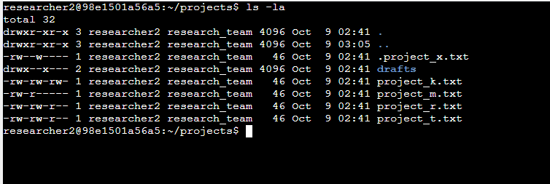

Describe the permissions string
In the above example
In the 10 character string from left to right the first is digit tells you if it is a directory or file, in this case the firstt character d means directory, the characters 2-4 is for the User = U, characters 5-7 is for group = g, and characters 8-10 is for O = other
So in the above example the drafts directory has given read, write and execute permissions to the users, execute permissions to the group and no permissions to Other - - -
d means directory if there is a – instead then it is a file being changed not a directory.
r = read only
w = write
x= execute

Change file permissions.

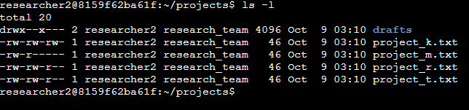The above example shows the previous permissions settings before making any changes.

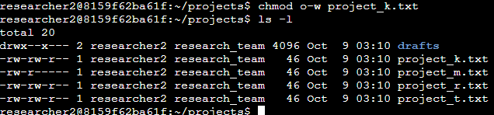
The second example shows that the chmod o-w project_k.txt command has been used to change the permissions of project_k.txt so that the write permission was removed allowing only reading permissions in the other section. As the organization determined that the other should not have write access to any of their files.

Change file permissions on a hidden file

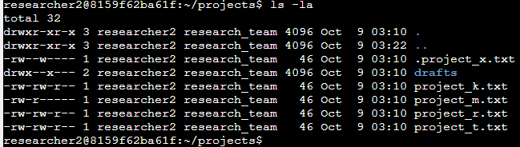

The research team at my organization recently archived project_x.txt. They do not want anyone to have write access to this project, but the user and group should have read access. The above example is to showcase the identification of the hidden files, as well as to show the previous permissions of the hidden file .project_x.txt before any changes have been made.
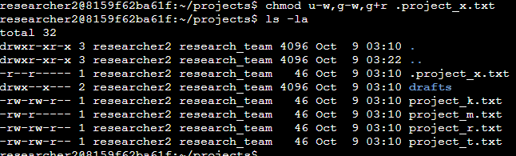
The second example shows that the chmod u-w,g-w,g+r .project_x.txt command has been used to remove the write permission from the user and group owners while the read command has been added to group. Now neither User or Group has permissions to write anything in the file.

Change directory permissions
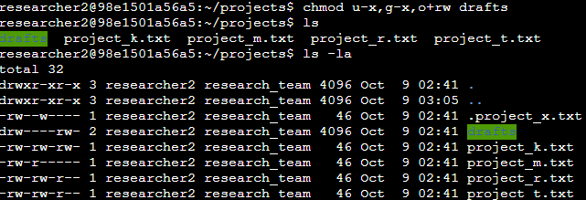 The following example above is an example of changed permissions.
The chmod u-x,g-x,o+rw drafts command changes the directory so that the users and group no longer has execute permissions, while granting the other permission to both read and write in the directory.

Summary
I changed multiple permissions to match the level of authorization my organization wanted for files and directories in the project’s directory. The first step in this was using ls -la to check the permissions for the directory. This informed my decisions in the following steps. I then used the chmod command multiple times to change the permissions on files and directories.

